|  |  |  |  |
| --- | --- | --- | --- |
| **Dimensions** | **non-zero elements** | **Left Window Size** | **Right Window Size** |
| 2000 | 100 | 3 | 3 |

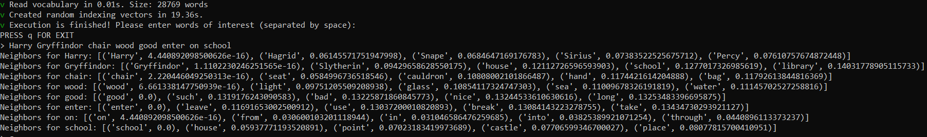

|  |  |  |  |
| --- | --- | --- | --- |
| **Dimensions** | **non-zero elements** | **Left Window Size** | **Right Window Size** |
| 10 | 8 | 3 | 3 |

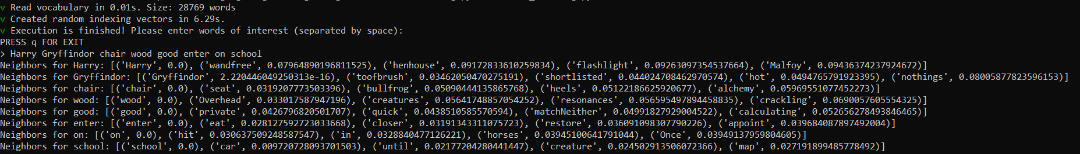

|  |  |  |  |
| --- | --- | --- | --- |
| **Dimensions** | **non-zero elements** | **Left Window Size** | **Right Window Size** |
| 2000 | 1600 | 3 | 3 |

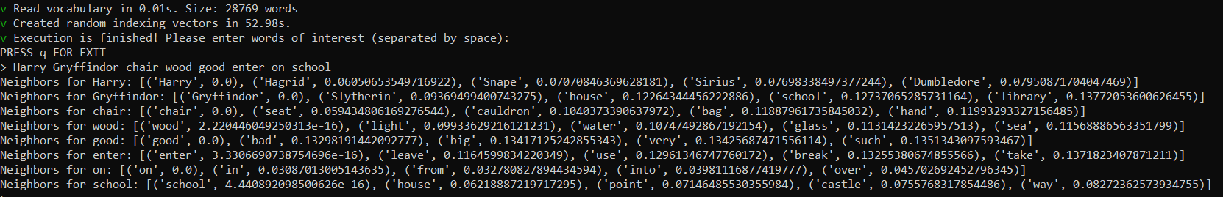

|  |  |  |  |
| --- | --- | --- | --- |
| **Dimensions** | **non-zero elements** | **Left Window Size** | **Right Window Size** |
| 4000 | 200 | 3 | 3 |

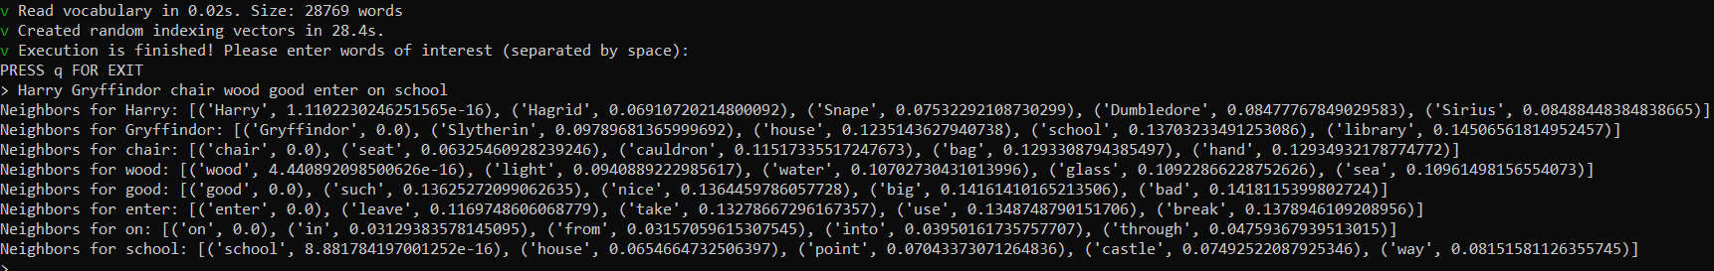

|  |  |  |  |
| --- | --- | --- | --- |
| **Dimensions** | **non-zero elements** | **Left Window Size** | **Right Window Size** |
| 50 | 3 | 3 | 3 |

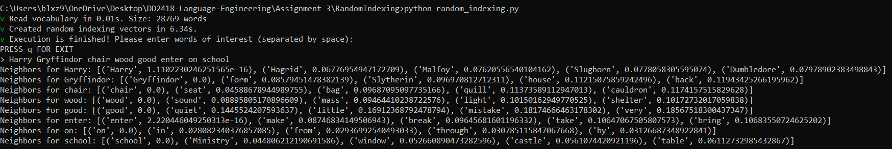

|  |  |  |  |
| --- | --- | --- | --- |
| **Dimensions** | **non-zero elements** | **Left Window Size** | **Right Window Size** |
| 300 | 15 | 3 | 3 |

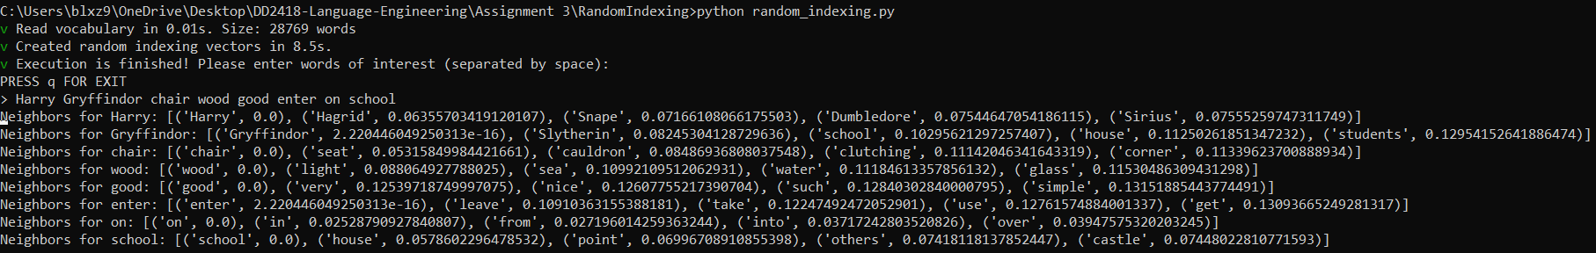

|  |  |  |  |
| --- | --- | --- | --- |
| **Dimensions** | **non-zero elements** | **Left Window Size** | **Right Window Size** |
| 300 | 15 | 2 | 2 |

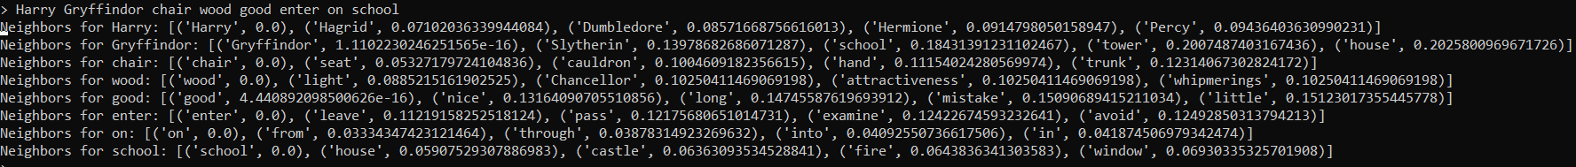

|  |  |  |  |
| --- | --- | --- | --- |
| **Dimensions** | **non-zero elements** | **Left Window Size** | **Right Window Size** |
| 300 | 15 | 10 | 10 |

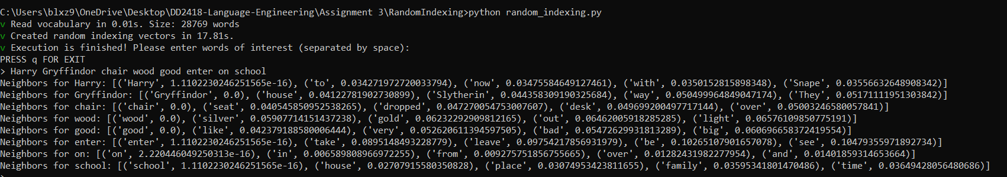

|  |  |  |  |
| --- | --- | --- | --- |
| **Dimensions** | **non-zero elements** | **Left Window Size** | **Right Window Size** |
| 300 | 15 | 2 | 3 |

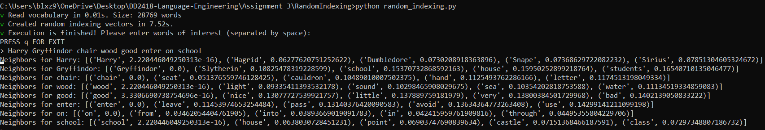

|  |  |  |  |
| --- | --- | --- | --- |
| **Dimensions** | **non-zero elements** | **Left Window Size** | **Right Window Size** |
| 300 | 15 | 3 | 3 |

If ***minkowski:***

